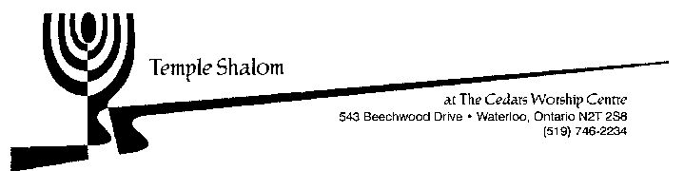

Temple Shalom Religious School
Registration Form 2025-26

Student Name | Hebrew Name | Birth Date | Grade | Fee

Total ________
Family information:
€ Returning student, same contact information as last year
€ New student, or updated contact info; please provide your contact information below:
Parent /Guardian Name: ________________________________ Phone # ______________________________
Street Address: ________________ _______________________ Cell # ________________________________
City: ______________________ Postal code: ________________ E-mail: _______________________________
Parent/Guardian Name:__________________________________ Phone # if different______________________
E-mail if different: _____________________ _________________ Cell # if different________________________

Program | Days and Times | Member Fee | Non-Member Fee
Hebrew and Judaic combined program | Saturday  10:00 to 12:00 | $360 per student | $500 per student

Registration must be completed BEFORE admittance to class

Registration forms are due by Sept. 5th, to be sent to education@templeshalom.ca.
Tuition may be paid by e-transfer, sent to the Temple Shalom treasurer (treasurer@templeshalom.ca).
Tuition is due with registration unless other arrangements are made with the Temple Board.

Please contact education@templeshalom.ca with any questions about the Religious School.

